World Immunization Week 2020
Social Media Toolkit

This is a toolkit created by the Rotavirus Organization of Technical Allies (ROTA), which promotes the use of rotavirus vaccines as part of a comprehensive approach to addressing childhood diarrheal disease.

For more information, visit preventrota.org or tag us @ROTACouncil on Twitter.

Twitter Handles to Tag

CDC | @CDCgov
DefeatDD | @DefeatDD
Gavi, the Vaccine Alliance | @gavi
Johns Hopkins International Vaccine Access Center | @IVACtweets
John Snow Inc. (JSI) | @JSIhealth
PATH | @PATHtweets
Sabin Vaccine Institute | @sabinvaccine
Shot@Life | @ShotAtLife
UNICEF | @UNICEF
World Health Organization (WHO) | @WHO
Manufacturers of WHO-prequalified rotavirus vaccines
Bharat Biotech (ROTAVAC) | @BharatBiotech
GlaxoSmithKline (ROTARIX) | @GSK
Merck & Co. (RotaTeq) | @Merck
Serum Institute of India (ROTASIIL) | @SerumInstIndia

Hashtags to Use
#WIW2020
#VaccinesWork
#Rotavirus
#Vaccination
#Immunization

Suggested Posts
Click on image to download. Copy and paste messages to share on social media channels.

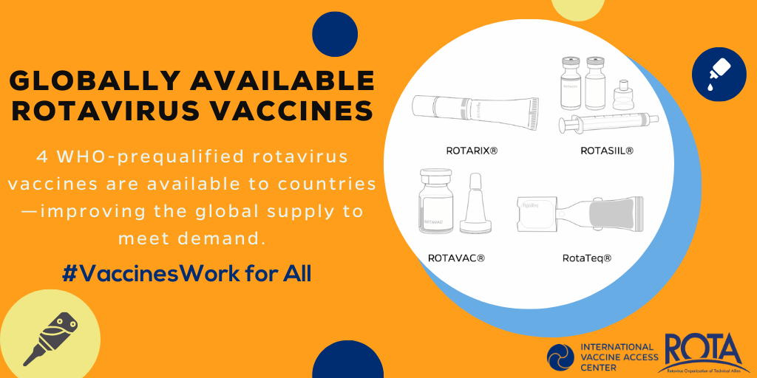
Tweet #1
For #WIW2020, we celebrate the power that immunization is having today in some of the world’s resource poor countries. 4 globally available #rotavirus vaccines are helping protect infants worldwide. #VaccinesWork bitly.com/ROTAbriefs

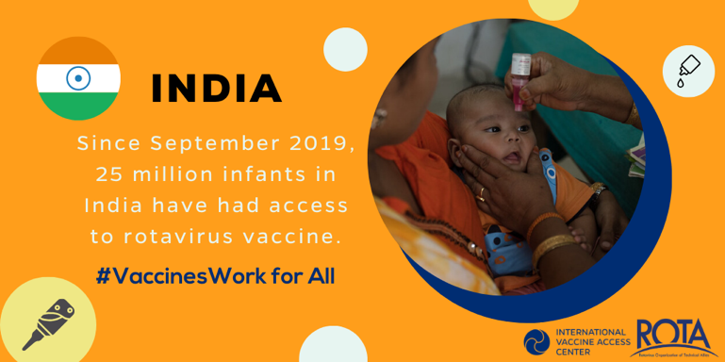
Tweet #2
ICYMI #rotavirus vaccine is now used in all states in #India! Vaccinating children👶🏽 will help reduce child diarrheal deaths. #WIW2020 #VaccinesWork

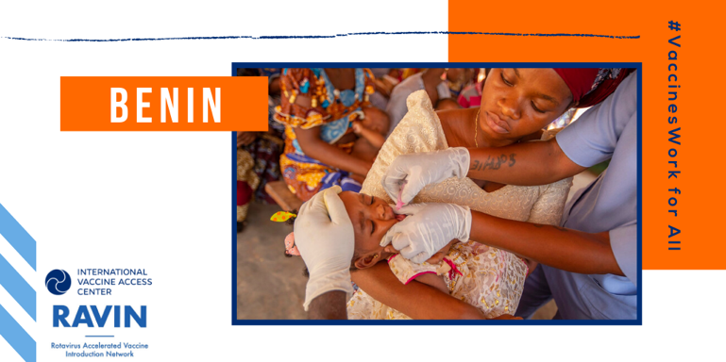
Tweet #3
#DYK Benin has one of the highest #rotavirus mortality rates in the world? Thanks to #ROTAVAC introduction, infants in #Benin are now being protected. #WIW2020 #VaccinesWork

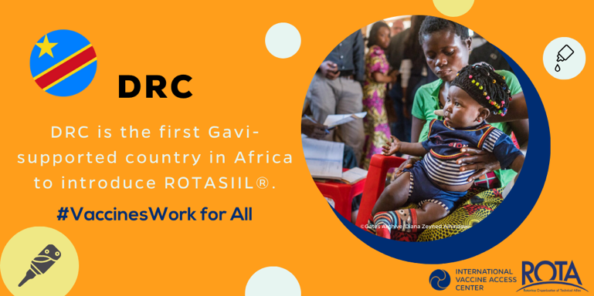
Tweet #4
#TBT to October when #DRC introduced #rotavirus vaccine in its national immunization program! DRC accounted for 7% of all global rotavirus deaths in children <5 #WIW2020 #VaccinesWork

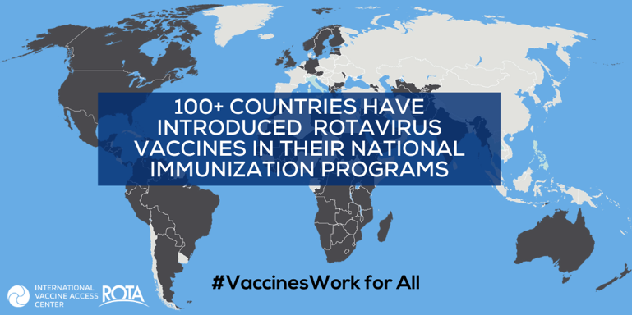
Tweet #5

Let’s celebrate some of the countries that have introduced #rotavirus vaccine in the last year on #WIW2020! #VaccinesWork

🇦🇱 Albania
🇧🇯 Benin
🇨🇩 Democratic Republic of Congo
🇰🇬 Kyrgyzstan
🇲🇲 Myanmar
Sweden
🇹🇱 Timor-Leste
🇹🇲 Turkmenistan

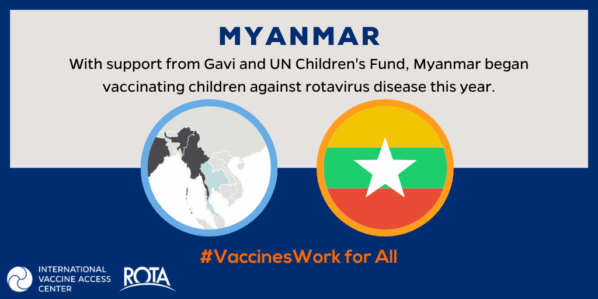
Tweet #6

In February, #Myanmar joined the other 100+ countries in introducing #rotavirus vaccine into its national immunization program👏👏👏 #WIW2020 #VaccinesWork bit.ly/2OHCGr2

Tweets for RAVIN Benin Video
Click on image to download the video.
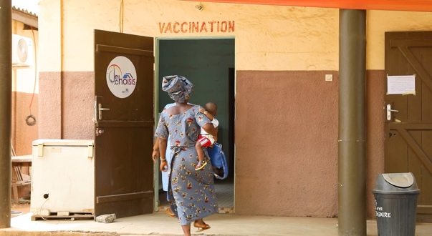
Tweet #7
Check out a short film about #ROTAVAC rotavirus vaccine💧 introduction in #Benin🇧🇯 and learn why #rotavirus vaccination is so important! #VaccinesWork #WIW2020 bit.ly/3aAGX7y

Tweet #8
#Benin introduced the #rotavirus vaccine into their national immunization program with support from @IVACtweets, @JSIhealth, and @CDC. Radio stations across the country played this song to convey the importance of rotavirus vaccination! #VaccinesWork #WIW2020
Tweet #9
For #WIW2020, we celebrate #ROTAVAC rotavirus vaccine introduction in Benin. To launch the #rotavirus vaccine, radio stations across the country played this awesome song #VaccinesWork bit.ly/3aAGX7y

Tweet #10
Listen to this awesome song that was played on radio stations across #Benin to celebrate #rotavirus vaccine introduction! With a #rotavirus mortality rate of 77 deaths per 100,000, infants in Benin are now being protected! #VaccinesWork

